Задача 11. Найти производную.
11.1. 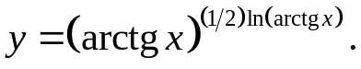
lny= 1/2*ln²arctgx
y'= (arctgx)^{1/2*ln(arctgx)}(lnarctgx)/(arctgx*(1+x²))
11.2. 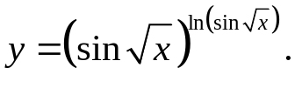
lny= ln²sin√x
y'= ((sin√x)^{lnsin√x}*ctg√x*lnsin√x)/√x
11.3. 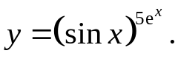
lny= 5e^{x}lnsinx
y'= (sinx)^{5e^x}(5e^{x}lnsinx+5e^{x}ctgx)
11.4. 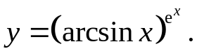
lny= e^{x}lnarcsinx
y'= (arcsinx)^{e^x}(e^{x}lnarcsinx+e^{x}/√(1-x²))
11.5. 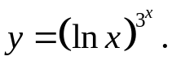
lny= 3^{x}lnlnx
y'= (lnx)^{3^x}(3^{x}ln3lnlnx+3^{x}/(xlnx))
11.6. 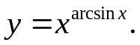
lny= arcsinxlnx
y'= x^{arcsinx}(lnx/√(1-x²)+arcsinx/x)
11.7. 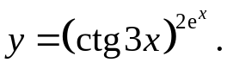
lny= 2e^{x}lnctg3x
y'= 2(ctg3x)2^{e^x}(e^{x}lnctg3x-3e^{x}/(ctg3x*sin²3x))
11.8. 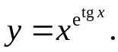
lny= e^{tgx}lnx
y'= x^{e^tgx}((e^{tgx}lnx)/cos²x+e^{tgx}/x)
11.9. 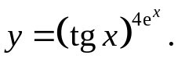
lny= 4exlntgx
y'= (tgx)^{4e^x}(4e^{x}lntgx+ 4e^{x} ) = (tgx)^{4e^x}(4e^{x}lntgx+ 4e^{x} ) =
tgxcos²x sinxcosx
11.10. 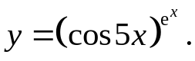
lny=exlncos5x
y'= (cos5x)^{e^x}(e^{x}lnco5x-5e^{x}sin5x)= e^{x}(cos5x)^{e^x}(lncos5x-5tg5x)
cos5x
11.11. 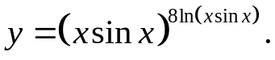
lny= 8ln²(xsinx)
y'= 16(xsinx)^{8ln(xsinx)}ln(xsinx)(sinx+xcosx)
11.12. 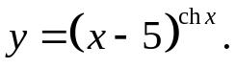
lny= chxln(x-5)
y'= (x-5)^{chx}(shxln(x-5)+chx/(x-5))
11.13. 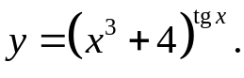
lny= tgxln(x3+4)
y'= (x³+4)^{tgx}(ln(x³+4)/cos²x+(3x²tgx)/(x³+4))
11.14. 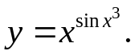
lny= sinx³lnx
y'= x^{sinx^3}(3x²cosx³lnx+(sinx³)/x)
11.15. 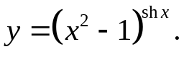
lny= shxln(x²-1)
y'= (x²-1)^{shx}(chxln(x²-1)+(2xshx)/(x²-1))
11.16. 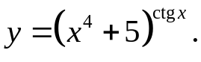
lny= ctgxln(x4+5)
y'= (x⁴+5)^{ctgx}(-(ln(x⁴+5))/sin²x+(4x³ctgx)/(x⁴+5))
11.17. 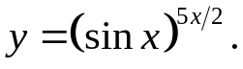
lny= 5x/2*lnsinx
y'= (sinx)^{5x/2}(2,5lnsinx+(5xcosx)/sinx)= (sinx)^{5x/2}(2,5lnsinx+5xctgx)
11.18. 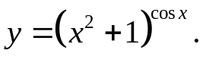
lny= cosxln(x2+1)
y'= (x²+1)^{cosx}(-sinxln(x²+1)+(2xcosx)/(x²+1))
11.19. 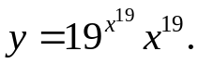
lny= x¹⁹ln19+19lnx
y'= 19^{x^19}x¹⁹(19x¹⁸ln19+19/x)
11.20. 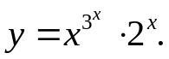
lny= 3^{x}lnx+xln2
y'= x^{3^x}2^{x}(3^{x}ln3lnx+3^{x}/x+ln2)
11.21. 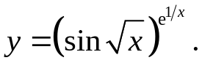
lny= e^{1/x}lnsin√x
y'= (sin√x)^{e^1/x}(-(^{e1/x}lnsin√x)/x²+(e^{1/x}cos√x)/(2√xsin√x))=
= e^{1/x} (sin√x)^{e^1/x}((ctg√x)/(2√x)-(lnsin√x)/x²)
11.22. 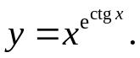
lny= e^{ctgx}lnx
y'= x^{e^ctgx}(-(e^{ctgx}lnx)/sin²x+e^{ctgx}/x)= e^{ctgx}x^{e^ctgx}(1/x-(lnx)/sin²x)
11.23. 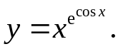
lny= e^{cosx}lnx
y'= x^{e^cosx}(-e^{cosx}sinxlnx+e^{cosx}/x)= e^{cosx}x^{e^cosx}(1/x-sinxlnx)
11.24. 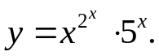
11.25. 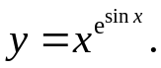
lny= e^{sinx}lnx
y'= x^{e^sinx}(e^{sinx}cosxlnx+e^{sinx}/x)= e^{cosx}x^{e^cosx}(cosxlnx+1/x)
11.26. 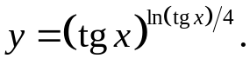
lny= ln²(tgx)/4
y'= (tgx)^{ln(tgx)/4}/*(ln(tgx))/(2cos²x)
11.27. 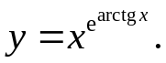
lny= e^{arctgx}lnx
y'= x^{e^arctgx}((e^{arctgx}lnx)/(1+x²)+ e^{arctgx}/x)
11.28. 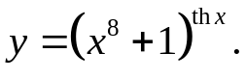
lny= thxln(x⁸+1)
y'= (x⁸+1)^{thx}((ln(x⁸+1))/ch²x+(8x⁷thx)/(x⁸+1))
11.29. 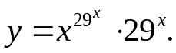
lny= 29^{x}lnx+xln29
y'= x^{29^x}29^{x}(29^{x}ln29lnx+29^{x}/x+ln29)
11.30. 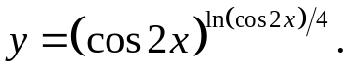
lny= ln²(cos2x)/4
y'= (cos2x)^{ln(cos2x)/4}(-ln(cos2x)sin2x)/cos2x
11.31. 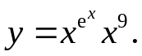
lny= e^{x}lnx+9lnx
y'= x^{e^x}x⁹(e^{x}lnx+e^{x}/x+9/x)

